**4. Standardization/Calibration**

* Testing is done in a controlled 23℃ room with vinyl flooring.
* Testing must be done to the fully assembled product no more than 48 hours after manufacturing time

**5. General Requirements**

* No hazardous points or edges
* No lead-based paint
* No small parts defined by image below or code 16 CFR 1501
  + 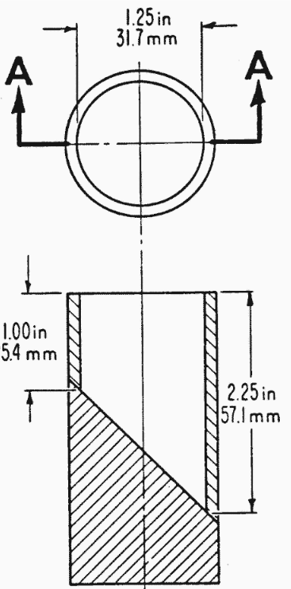
* Exposed wood must be smooth and splinterless
* Hinges
  + Must prevent folding when in open/normal use position
    - Both hinge and frame remain intact and in proper position under load
  + Hinged links need at least 2 separate actions to fold
    - Only need one to open though
* Holes/openings
  + If material is less than 9.53mm thick, if it is able to admit a 5.33mm object, it must then also be able to admit a 9.53mm object.
    - If hole does not go all the way through, then this does not apply
* Scissoring/Shearing/Pinching
  + When in intended use position, it should be design so it prevents any injury from any movements
    - It can cause injury if a 5.33mm probe can fit in the gap, but a 9,53mm one cannot
  + Same requirements for saddle hinges
  + Same requirements for canopy hinges
    - However, Canopy stretching/locking devices are exempt
    - Canopy rods and stops are exempt if the rod does not pass over or through the rod
  + Actual frame folding strollers must also comply with the above
    - Carriages (babies lying down) are exempt
    - If the seat is removable to allow for folding, it is also exempt
* Exposed Coil Springs
  + If the spring can create a space of minimum 5.33mm, it must be covered
* Labeling
  + Warnings must be permanent
  + Non-paper labels must not break apart into small parts
* Cord/Strap Length
  + Straps cannot exceed an internal perimeter of 376mm
  + Cannot stretch more than 188mm
  + If they are used to restrain an occupant, carry straps, attachment straps to infant carriers are all exempt
* Strap/Trap/Grab bar
  + The actual bar does not contain foam
    - Can be padded with foam, but must be covered
      * The overeating cannot come off and the foam cannot disintegrate

**6. Performance Requirements**

* Parking Brake
  + Parking brake must be included
  + Brake must prevent wheels from rotating under 1.25x described load or 100lbs, whichever is greater
    - After this test, it must still work
  + Cannot be accessed from the seat
  + If it is a single action release mechanism, must release with minimum 45N of force
    - Otherwise, must be dual action
* Static Load
  + Carriage must support 50 lbs at center of seated area
  + Stroller must support 100 lbs or 2.5x manufacturer max recommended weight at center of seated area, whichever is greater
  + A convertible must pass both requirements
  + Steps/footrests must support 50 lbs or 1.25 max recommended weight
* Stability
  + Must not tip over when tilted at 12 degrees in all directions
* Restraining system
  + All strollers must have a restraining system
    - Carriages intended for infants are exempt
    - If they have sitting mechanisms, or something else intended for children beyond infancy, then must have a restraining system
  + Cannot become detached through normal use
  + Must come pre assembled for a stroller
  + Convertible must have one when functioning as a stroller
  + When a 200N force is applied, system and buckle cannot slip more than 25mm
  + 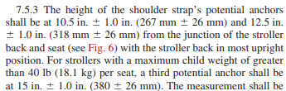
  + A 1 inch probe must not pass through any point
  + The buckle can be single action with a minimum required opening force of 40N
    - Otherwise, must be dual action
* Occupant Retention
  + Must have sides and floor walls
  + Said walls cannot be detachable
* Impact
  + The following test is administered:
  + 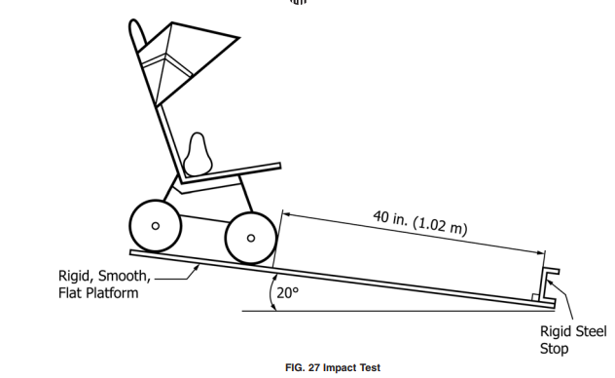
  + Stroller must survive, and dummy inside must not shift
* Containment
  + Grab bar must allow head to pass, but not torso
* Wheels
  + Wheels and swivel parts must not detach under normal use
  + If it is removable, needs a secondary system
* Head entrapment
  + No opening shall allow passage or entrapment of head